

Dashboard: User Guide

Updated September 07, 2021
DCN Dshbrd-UG-002
Version 1.2

Table of Contents
FranchiCzar OS: Dashboard 3
What are Widgets? 3
Why Should I use Widgets? 3
Getting Started 3
Dashboard 4
Adding Widgets 4
Selection Page 5
Preview 6
Add to Dashboard 7
View Dashboard 8
Version History Table 9

FranchiCzar OS: Dashboard

What are Widgets?
Generally, widgets are a way to access information from applications without having to open that application.

You most likely use or benefit from widgets every day. Most of the apps on your phone have widget counterparts, like your calendar or weather applications. When you can see an appointment on your calendar or the weather without opening the app, this is a widget doing its job.

For FranchiCzar OS, widgets provide users a snapshot of more complex data directly to your Dashboard. This means you can save time and access information pertinent to your operations.

Why Should I use Widgets?
Having widgets added to your Dashboard allows you to quickly view data that would otherwise take significantly more time to access. This ease-of-access to view custom data frees you to apply yourself where and however you need.

Getting Started
The FranchiCzar OS Dashboard provides users the ability to create a custom snapshot of the data that is most important.

Once you add Widgets, they will be the first thing you see after logging in to FCOS. The Dashboard is the default landing page.


You can always navigate back to the Dashboard via the first (top) option from the vertical menu on the left side of the browser.

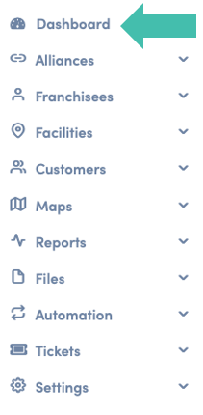

Dashboard
When you select Dashboard (top of left-hand vertical menu), before any Widgets are added, you see the dashboard landing page. This is where you add Widgets to customize your dashboard.

Adding Widgets
To begin customizing your Dashboard click on the  button (either at the top-right or on the “Sample Widget Card”).
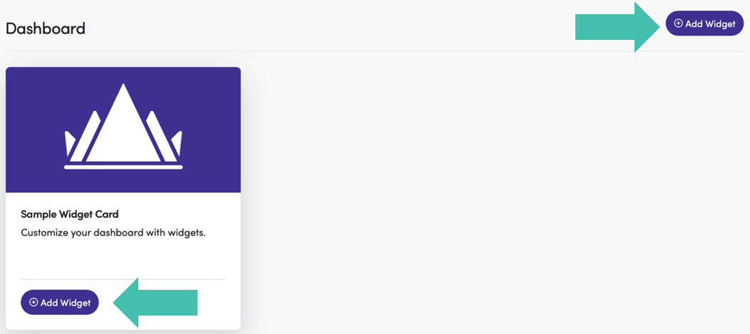

Selection Page
From the Widgets selection page, you choose any/all the widgets you would like to see/access from your Dashboard. Each Widget Card contains (from top to bottom),
- A brief description
- A button to Add to Dashboard
- A link to Preview the Widget
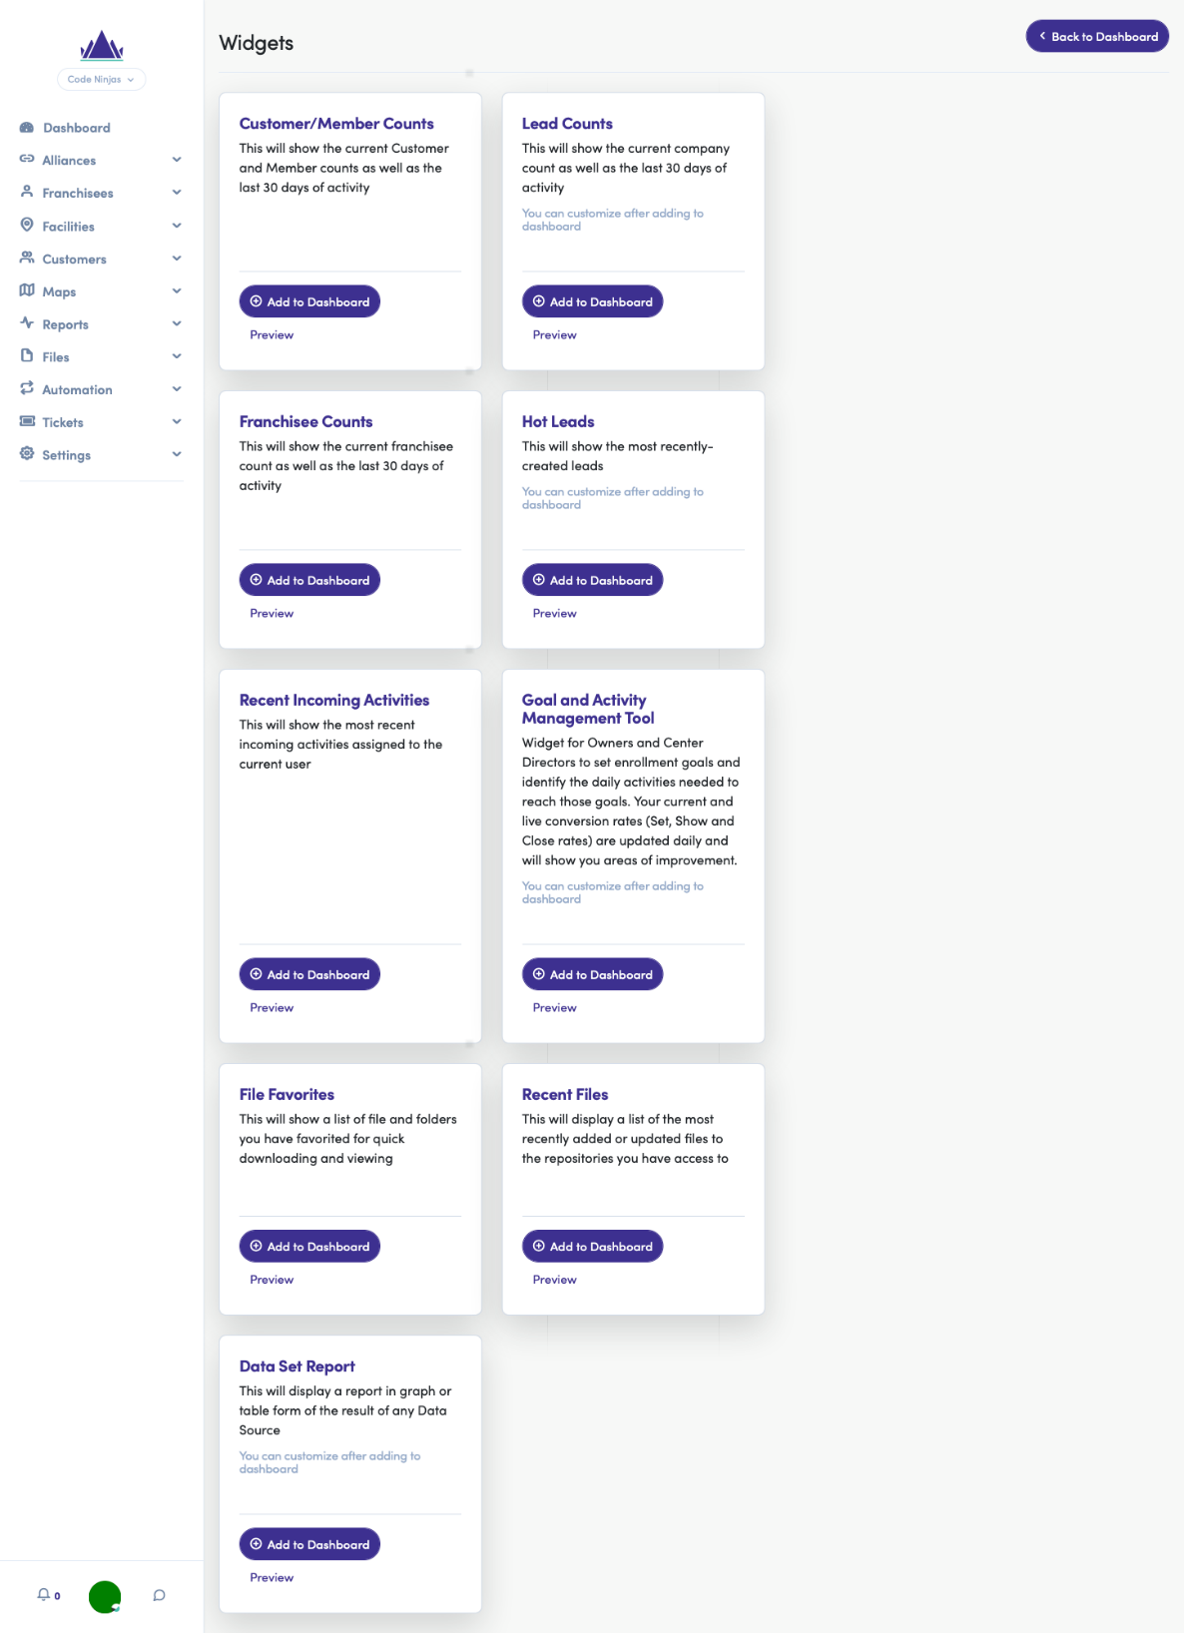

Preview
Click Preview to see an example of the Widget which will appear on the user’s Dashboard if clicked.

Users will see the following on the right side of the screen,
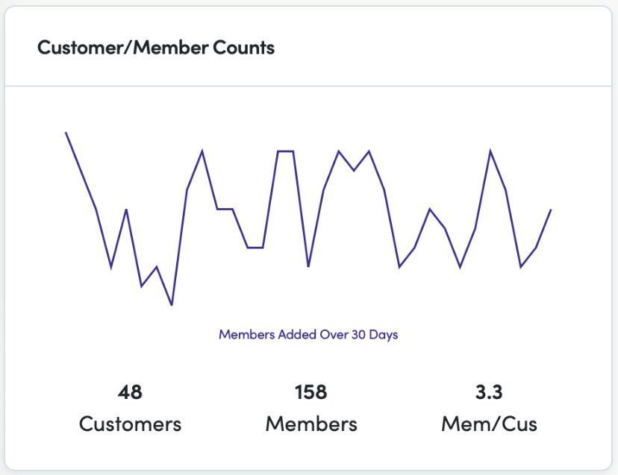


Widget Preview changes depending on the Widget.

Add to Dashboard
If the Widget’s description and “Preview” match your needs, click 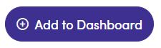 to add the Widget to Dashboard (see image below).
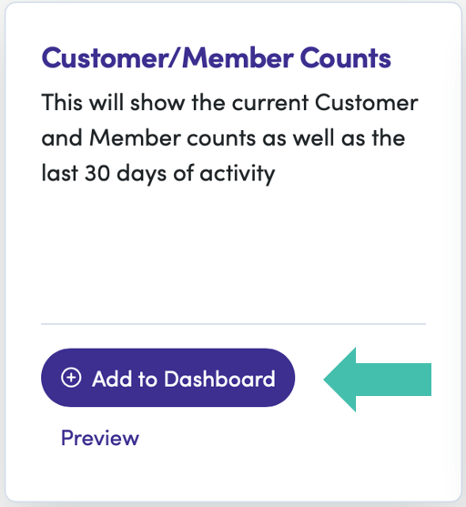


The user will see a confirmation in the upper right corner of the screen, 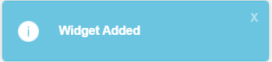, once the widget is added to the dashboard.

View Dashboard
Once all Widgets of interest have been added to the User’s Dashboard, click 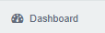 to see the updated Dashboard now containing the selected Widgets.
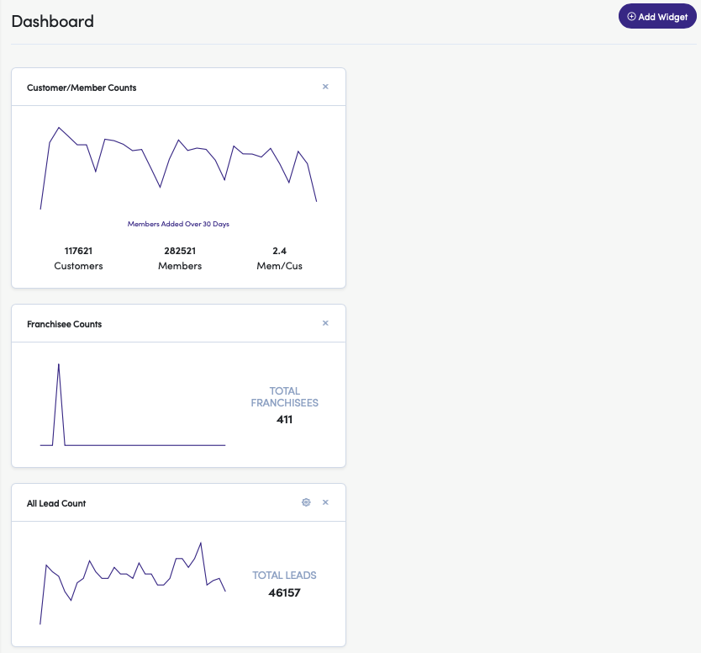


Users can also reorder and rearrange into side-by-side alignment by dragging and dropping the selected Widget.

Version History Table
Date | Version | Description | Owner | Approver
01/18/2021 | 1.0 | Original document completed | Shauna Garner
07/21/2021 | 1.1 | Updated,  - Applied General Doc Template  - Update document structure and content | John Beatty
09/07/2021 | 1.2 | Updated images to “flat” versions | John Beatty

